### Feedback (3/22/2023)

What font style are you using on the website? It’s currently hard to read, please suggest some other easy to read font styles

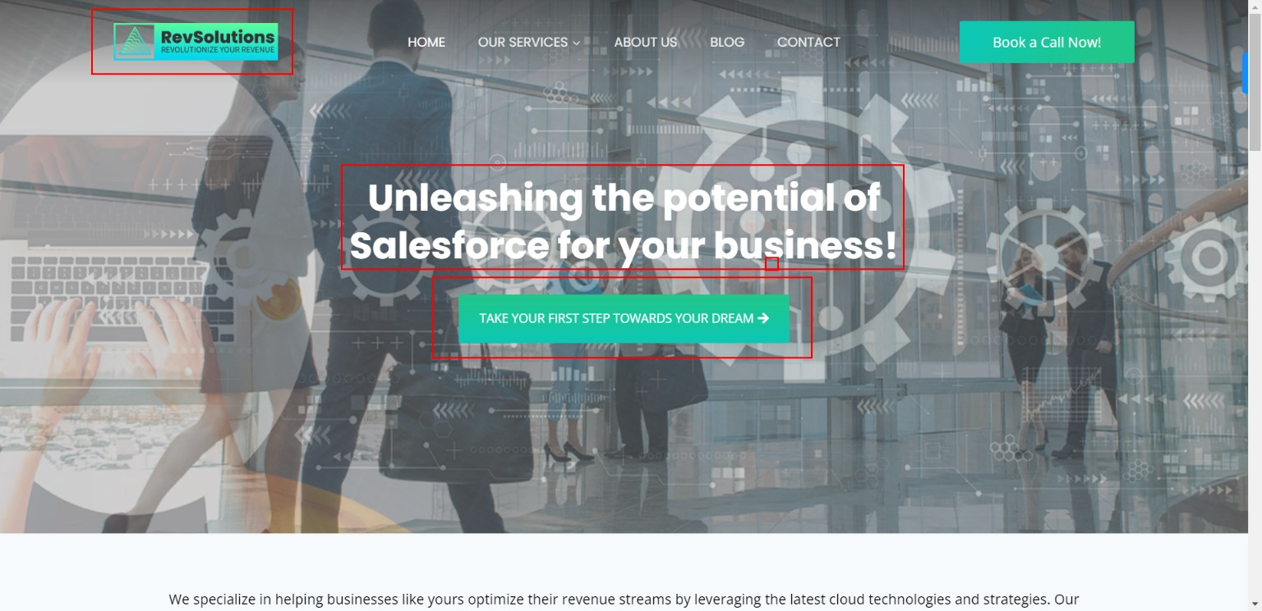

Change the logo text color to white in top left corner.

Remove Take “Your First Step button”

Text in white color is not readable, change the transparency of the current images to make it more darker or use a dark background consulting related images.

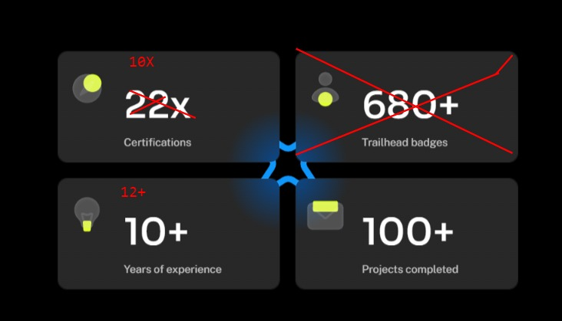

Add these 3 tiles under the Why RevSolutions section.

3 other tiles would be:

1. RESULTS-ORIENTED: QUICK IMPLEMENTATION COMPLETED ON TIME AND ON BUDGET

2. Revenue Focused: Control Your Revenue Trajectory, Provide a better customer experience, Create More Ways to Grow and Optimize Revenue Sources

3.

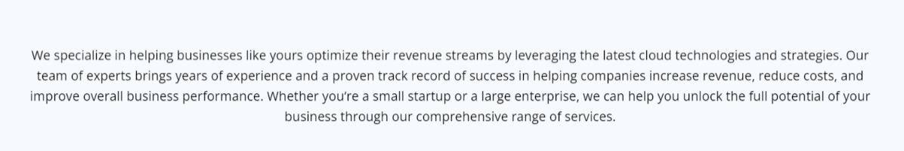

Move this text below “Why RevSolutions”

Remove “Take Action” button

Add a tab for “Resources” with sub-categories as Blog and Case Studies

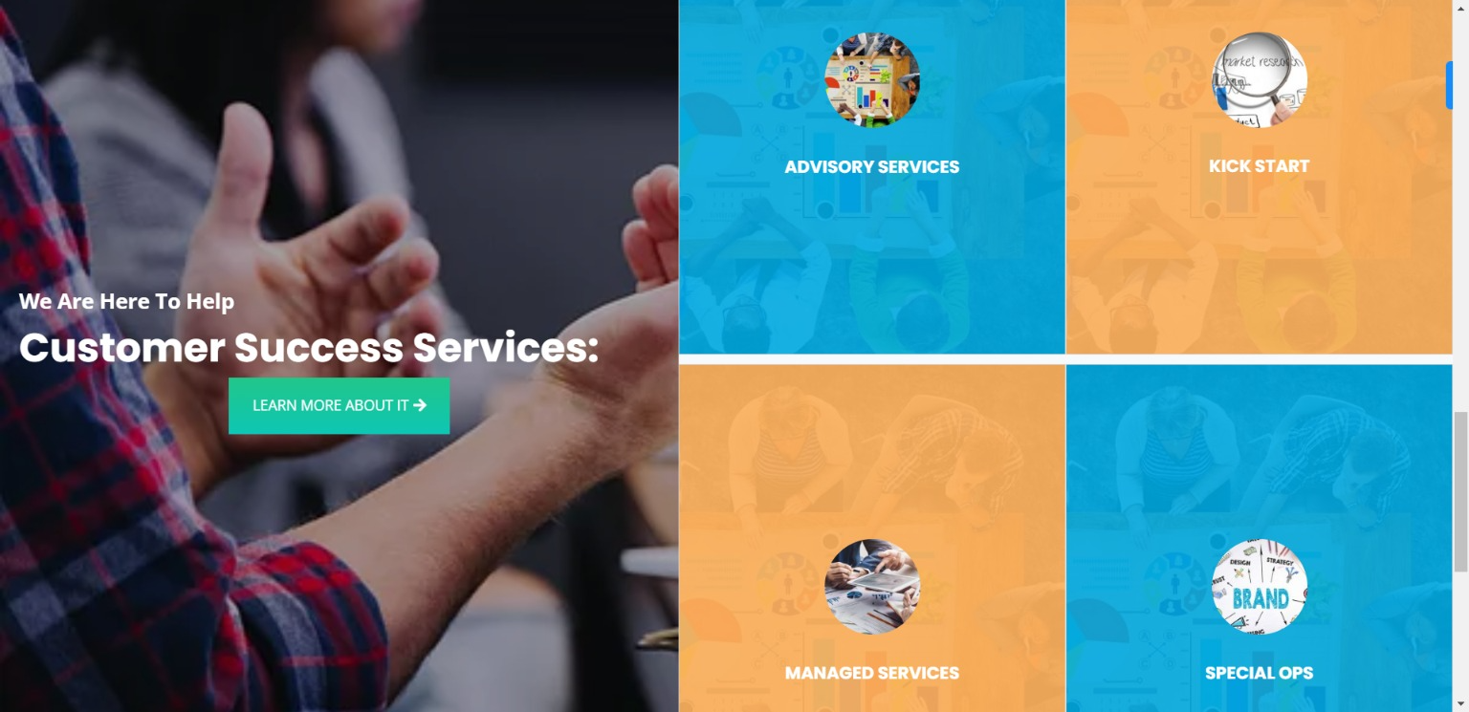

Instead of Orange color use the brand color on the tiles

Increase the image size and font size, also add better images related to the topic

Replace Special Ops with ‘Staff Augmentation’

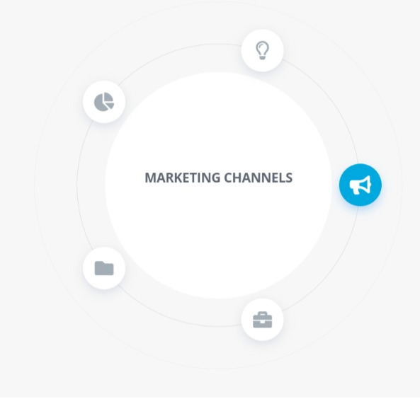

All these options should be auto-rotating.

Remove Learn How it works button

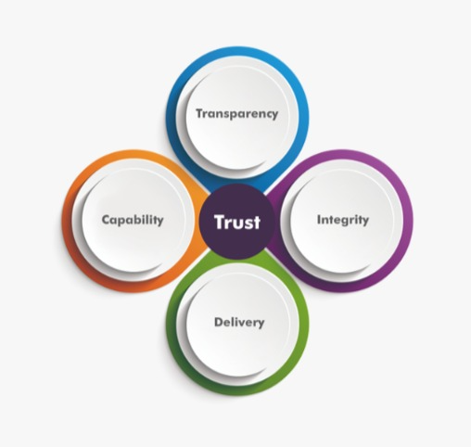

Increase the size of Trust, also use brand color codes.



Replace text with

Ready To Revolutize Your Revenue?

Speak with one of our certified Salesforce experts today.

### New Plan (3/14/2023)

* Clone Sage Consulting Website (<https://sageconsultingusa.com/>)
* Add the Gradient Blue and Gradient Green color theme
* Use the same images or similar images related to Salesforce CRM Consulting

### 

### 

### 

### 

### Sample Websites:

* <https://originalshift.com/>
* <https://neocol.com/>
* <https://cyntexa.com/>
* <https://www.foundhq.com/>

### Sample websites for content:

* <https://originalshift.com/>
* <https://neocol.com/>
* <https://www.hightideco.com/>

### Sample Themes:

* <https://digitalagency.liquid-themes.com/>
* <https://demos.cryoutcreations.eu/wp/esotera/>

### Sample Logo:

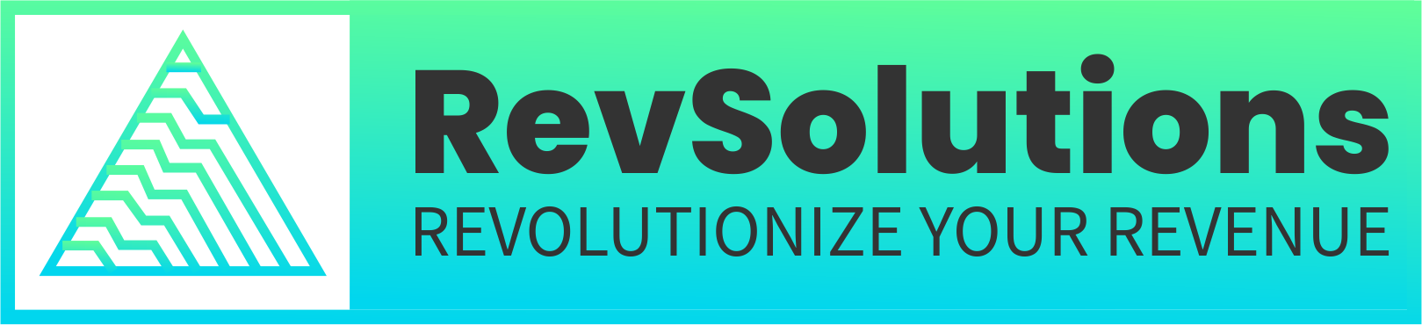

* RevSolutions font - Poppings
* Tagline font - SourceSans

Needs to be re-developed in high resolution

### Color theme:

* Gradient Blue and Gradient Green (reference <https://www.getxray.app/> )

### Website info:

* Domain GoDaddy - [www.revsolutions.co](http://www.revsolutions.co)
* Hosting - Namecheap

### CTA:

Add a Book a Call button with a calendly link: [https://calendly.com/cgulati_revs](https://calendly.com/cgulati_revs/30min)

## Home Page (Page 1):

Headline: Unleashing the potential of Salesforce for your business!

Your go-to partner for driving revenue growth through cloud-based solutions!

We specialize in helping businesses like yours optimize their revenue streams by leveraging the latest cloud technologies and strategies. Our team of experts brings years of experience and a proven track record of success in helping companies increase revenue, reduce costs, and improve overall business performance.

Whether you're a small startup or a large enterprise, we can help you unlock the full potential of your business through our comprehensive range of services.

Customer Success Services:

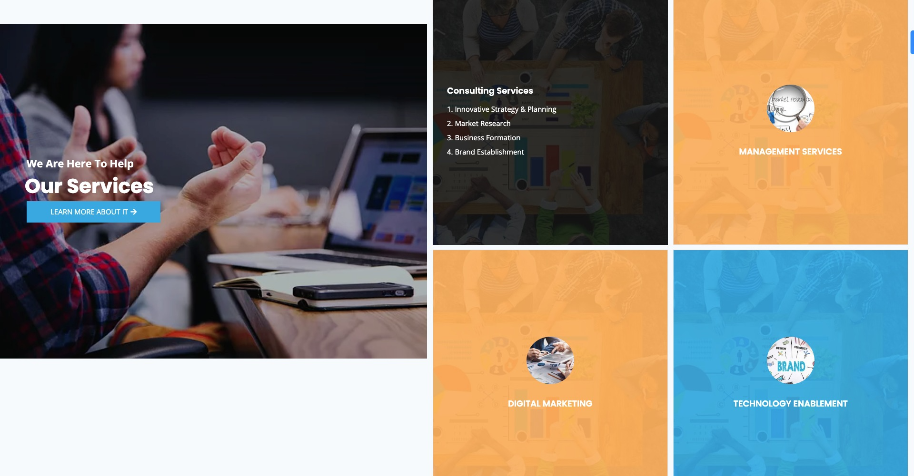

1. **Advisory Services**
2. **Kick Start**
3. **Managed Services**
4. **Staff Augmentation**

**Why RevSolutions?**

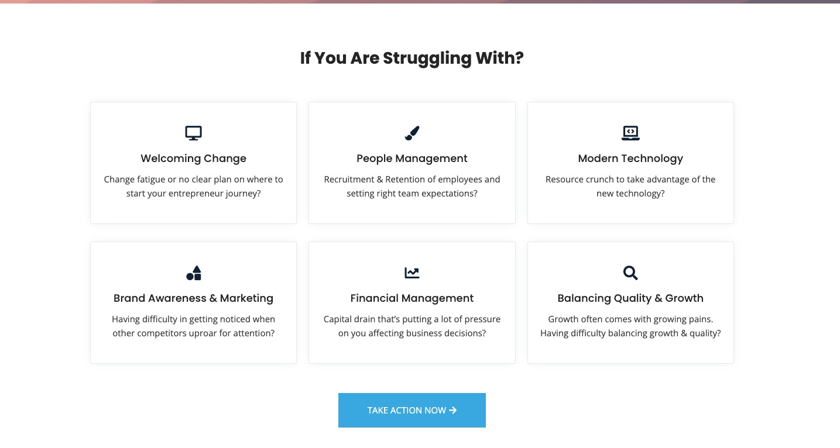

## 2) Services (Page 2):

**2.1 Advisory Services**

**2.2 Kick Start**

**2.3 Managed Services**

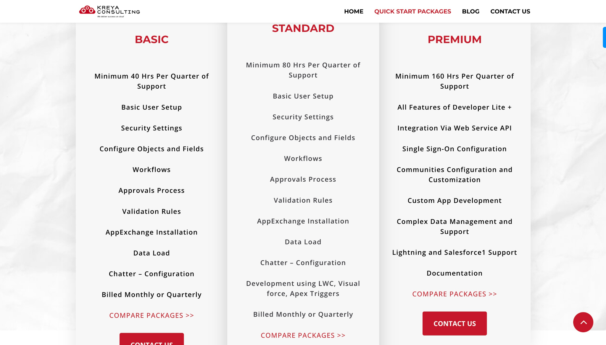

**2.4 Staff Augmentation**

## About Us (Page 3):

At RevSolutions, we pride ourselves on delivering high-quality services that are tailored to the unique needs of each of our clients. We work closely with you throughout the process, from initial consultation to ongoing support and maintenance.

If you're ready to take your business to the next level and drive revenue growth through cloud-based solutions, we're here to help. Contact us today to schedule a consultation with one of our experts!

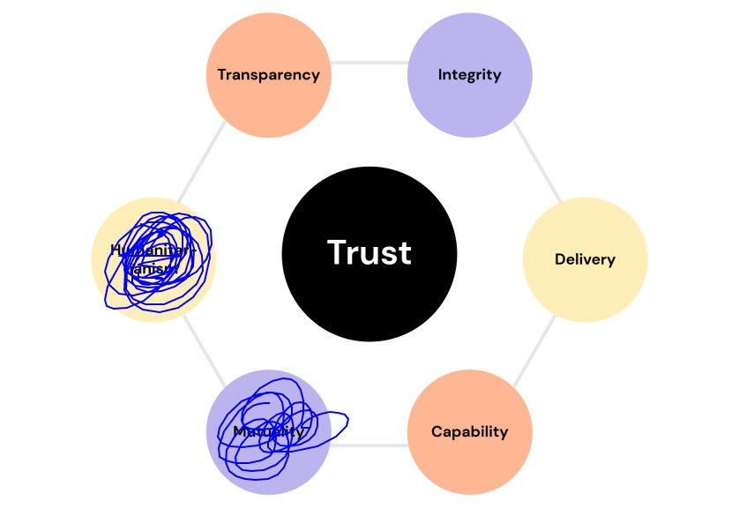

## Blog (Page 4):

## Contact

Address: 11 Apex Drive Suite 300A, Marlborough, MA 01752

Email: [info@revsolutions.co](mailto:info@revsolutions.co)